**Electricity Study Guide**

Like the charges in an Atom !

**Electric Charge**

Charge is a fundamental property of matter, like mass.

Objects are either positive, ____________, or____________.

**Protons** have a ___________ charge

**Neutrons** have a __________ charge

**Electrons** have a ___________ charge

Electric Charges work like magnetic poles.

Which two go inside the house (nucleus)?

__________ charges attract

________ charges repel

**Electrical forces cause electrons to move.**

***Electricity is moving electrons.***

Atoms contain an equal number of protons and electrons, so they cancel each other out.

When something **loses** electrons it becomes ______________ charged.

When something **gains** electrons it becomes ______________ charged.

BUT

Atoms can gain or lose electrons

Electric charges (-) are Electrons moving in a wire

**Current Electricity**

**Static Electricity**

building up in one place.

*Static* means **still**

C:\Documents and Settings\e200801456\Local Settings\Temporary Internet Files\Content.IE5\GKUZVLEN\MCj01500170000[1].wmf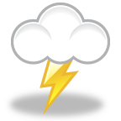

Lightening is a huge build up of

**______________ electricity**

in the clouds, just like when you drag your feet across a carpet. When enough charge is built up to break through the air, lightening occurs, releasing

the charge. You also **discharge** static electricity when you touch a doorknob.

**Current:** is the **flow** of electrons; just like water flows down a stream.

***Charged objects try to discharge because***

***all objects want to be electrically neutral.***

**Energy Source**

A **circuit** is the pathway that electrons travel through;

(Think of a sidewalk)

**Parts of a circuit**

**Conductor**

**Load**

C:\Documents and Settings\e200801456\Local Settings\Temporary Internet Files\Content.IE5\F7JUWLF3\MCj02153350000[1].wmfC:\Documents and Settings\e200801456\Local Settings\Temporary Internet Files\Content.IE5\X70APTWD\MCj04260720000[1].wmfUses electricity source of electrons

Pathway that gets electrons

from energy source to load

(wire)

**2 Types of Circuits**

**Parallel**

The World **Series** is several games, one after the other

**Series**

Has ___________________paths for

electrons to follow

Has only one __________ for

electrons to follow



Like parallel lines

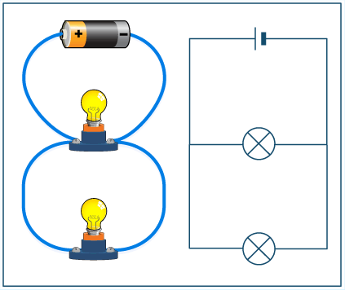

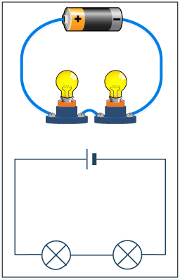

Turn one bulb off and they both go off

Your house is a

parallel circuit

More bulbs in a series circuit means they get dimmer

**Conductor**

Let’s electricity run through it Examples:

***Conductors of electricity also conduct heat, thermal energy.***

**Insulator**

Doesn’t let electricity run through it Examples:

Electrical wires have a metal center

to conduct electricity surrounded by

insulation for protection.

A. The charge that attracts protons.

B. A buildup of charge on an object.

C. A material that resists the flow of electricity.

D. movement of electrons from one place to another

E. The charge that attracts electrons.

F. A material that does not resist electricity.

G. The pushes and pulls that electric charges exert on each other

H. An object that has equal amounts of positive and negative charges.

1. Insulator

2. Conductor

3. Positive

4. Negative

5. Electricity

6. Electric charge

7. Static electricity

8. Electrically neutral

**Matching !**

Draw a line to connect the term to the meaning.

**I**nsulator? or **C**onductor?

After you rub a balloon on your hair it might stick to a wall.

**Why? Be specific.**

____ Silver

____ Wood

____ Air

____ Glass

____ Copper

____ Pure water

____ Gold

____ Styrofoam

____ Aluminum

**S**eries or **P**arallel circuit?

List three things you MUST have for a complete circuit:

1)

___ Only one path for the electricity.

___ Dependent paths.

___ How your house is wired.

___ Independent current paths.

___ Can turn off one light without others turning off.

___ If you turn off one light, all the lights turn off.

___ More than one path for the electricity to flow.

2)

3)

**NOTES:**

An atom that loses electrons becomes (negative/positive)? Circle one

An atom that gains electrons becomes (negative/positive)? Circle one