Electricity and Magnetism Study Guide

1. What happens when you cut two magnets in half?
2. Name three features of all magnets.
3. Where are the forces of magnets the strongest?
4. Name the components of a complete circuit.
5. A circuit that has more than one pathway for electrons to follow is a:
6. A magnet or piece of metal can feel the force of another magnet once it enters the area around a magnet called this:
7. Name the parts of an atom and give their charges.
8. Which part of an atom is responsible for the flow of electric current?
9. Explain which wire has the greatest resistance using the diagram below: A B

10. Explain which wire has the greatest resistance using the diagram below: A B

A

C

B

11. For the circuit diagram shown above, name and describe parts A, B and C and tell their function.

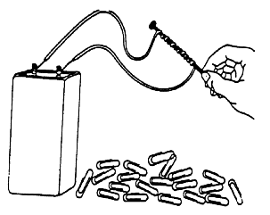

12. What is shown in the illustration above?
13. What will happen to the nail once a current is passed through it?
14. What will happen to the nails as they come into contact with the paper clips?

15. In the boxes below, draw arrows to indicate the direction of the atoms in the domains for an object that is magnetized and for one that is not.

Magnetized object Non-magnetized Object
16. Describe what happens to the brightness of bulbs in a series circuit when you add additional bulbs.
17. A allows electricity to easily pass through it because its are NOT
tightly bound to its nucleus.
18. A does not allow electricity to easily pass through it because its electrons ARE
bound to its nucleus.
19. Which would have lower resistance, a metal or a plastic? Why?
20. Describe the difference between static electricity and current electricity in terms of electron movement.
21. Describe the energy transformations taking place when a light bulb is powered by a battery, including why the battery diminishes over time.
22. When you rub a balloon on your hair, what type of charges do the balloon and your hair have?
23. Describe how electrons flow when a circuit is open:
24. Describe how electrons flow when a circuit is closed.

Please define the following terms: Atom
Electron

Electric Current Electric Circuit Series Circuit Parallel Circuit Load
Static discharge Resistance Magnetic Field

