PRACTICE TEST: Work and Simple Machines Name ________________________ Period:______
1. In an acceleration graph showing speed versus time, what does a flat, horizontal line show about acceleration?

2. What kind of line on a distance-versus-time graph indicates that the object is accelerating?

Use the diagram to answer the following questions
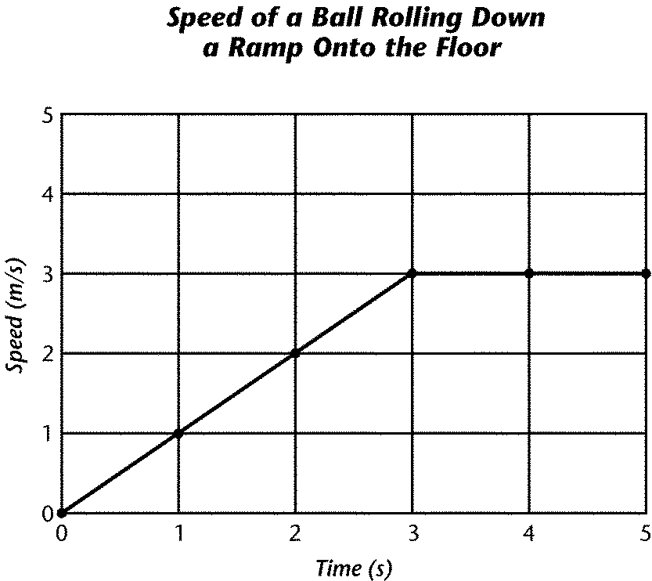
2.

3. What does the line segment on the graph from 0 to 2 seconds represent?

4. What is the acceleration of the ball between 0 and 2 seconds?

5. What happened to the speed of the ball during the final two seconds?

6. Does the graph indicate that the ball decelerated?

7. How far did the ball move in the final second?

8. What does the slope of the speed time graph from 1 to 3 seconds indicate?

9. Suppose your brother is riding his tricycle in a straight line and increases his speed from 30 m/s to 60 m/s in 10s. What is his acceleration?

10. Sound travels at 330 m/s. If Charles hears a train horn 30 m away, how long did it take for the sound to travel from the train horn to his ear?

11. If a ball rolls 80 feet in 40 seconds. What is its velocity?

12. A car has a velocity of 30 m/s. If it drives down a straight track for 1 minute, what is the total distance it has covered?

13. What simple machines might you use at a restaurant? (name two examples)

14. You need to get your car to the top of a mountain. Which simple machine would make your work easier?

15. 15. Which simple machines are found in a pair of scissors?

16. 16. Many simple machines are related to other simple machines. Based on what you know of simple machines. How are flagpoles related to classroom pencil sharpeners? (What is similar in their operations?)

- Which kind job would you use a pulley to complete?

- Which simple machine is used to make a screw?

- Name and describe three compound machines.

- What compound machine is a lever and a wedge?

- A ramp is an example of which simple machine?

- What type of simple machine is the tip of a dart?

- What is the triangle part of a see-saw called?

- A woman applied a force of 300N to push a dresser 15m across a room. How much work does she do?

- What is the power of an electric screwdriver that can do 520J of work in 5secs?

- A man applies a force of 500N to push a truck 10m down the street. How much work did he do?

- What must you do in order to do work on an object?

- A scientist measured the amount of work being done by a simple machine. The work that gets recorded was most likely measured in what unit?

- A pump with a power rating of 100W. How long will it take to do 20J of work

- A 100N person climbs 4 m high in 50 seconds. What is her power?

- You push a box a distance of 3m by exerting a force of 30N. How much work did you do?

- NO work is being done when you ______________ a ball.

- Simple machines can help us do things in different ways. How does an inclined plane help?

- What does a simple machine do to make work easier?

- If the force input applied to a machine is 10N and the force output produced by the machine is 120N, what is the mechanical advantage?

- In a simple machine, force output compared to force input is called what?

- Give the MA of the following machines:
- A machine in which the input force is 4N and the output force is 12N
- A machine in which the input force is 12N and the output force is 12N

